CS 255 System Design Document Template

UML Diagrams

UML Use Case Diagram

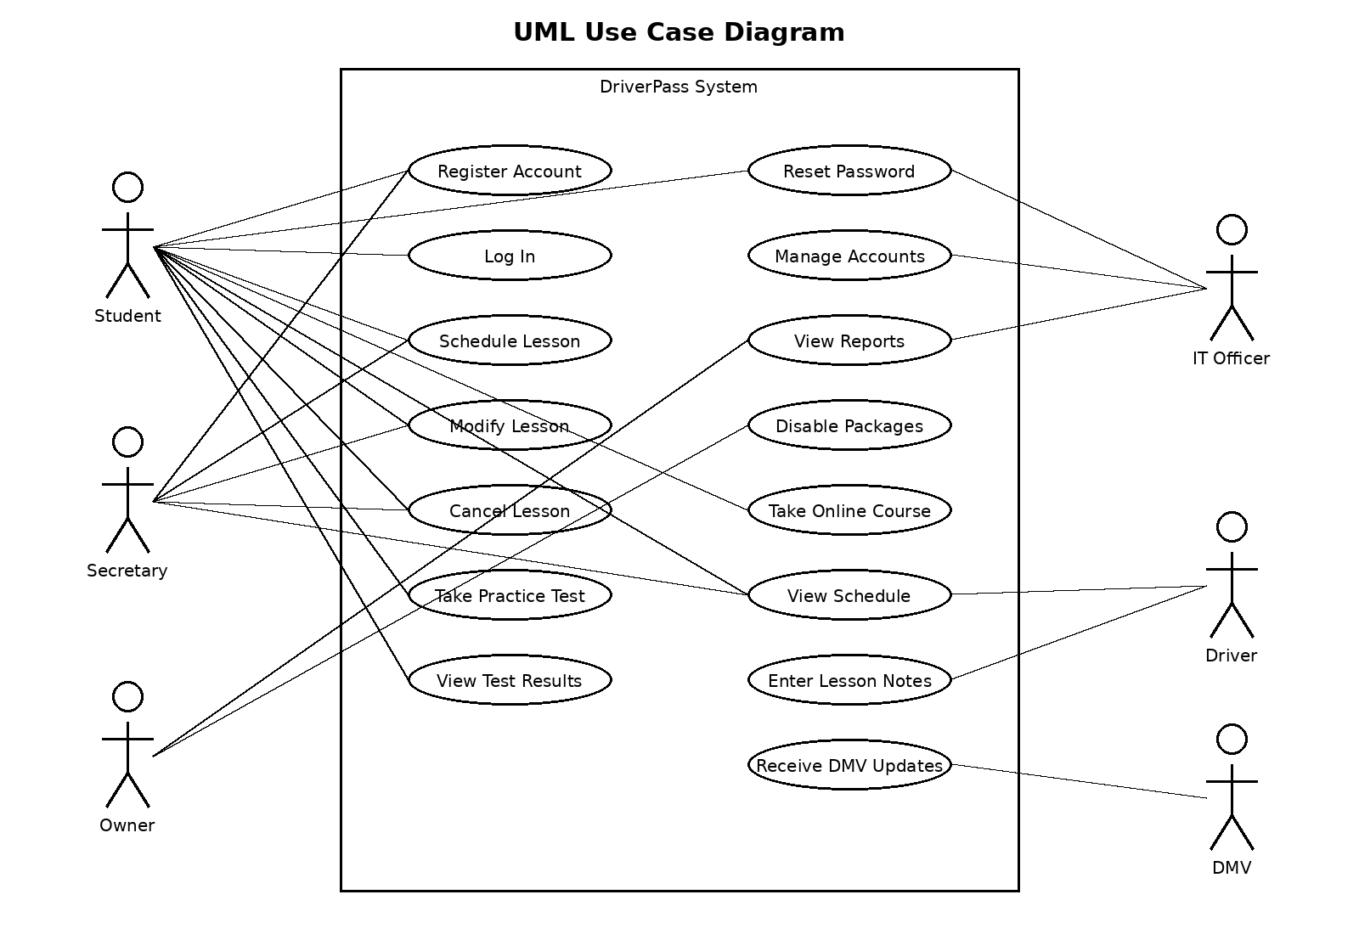

UML Activity Diagrams

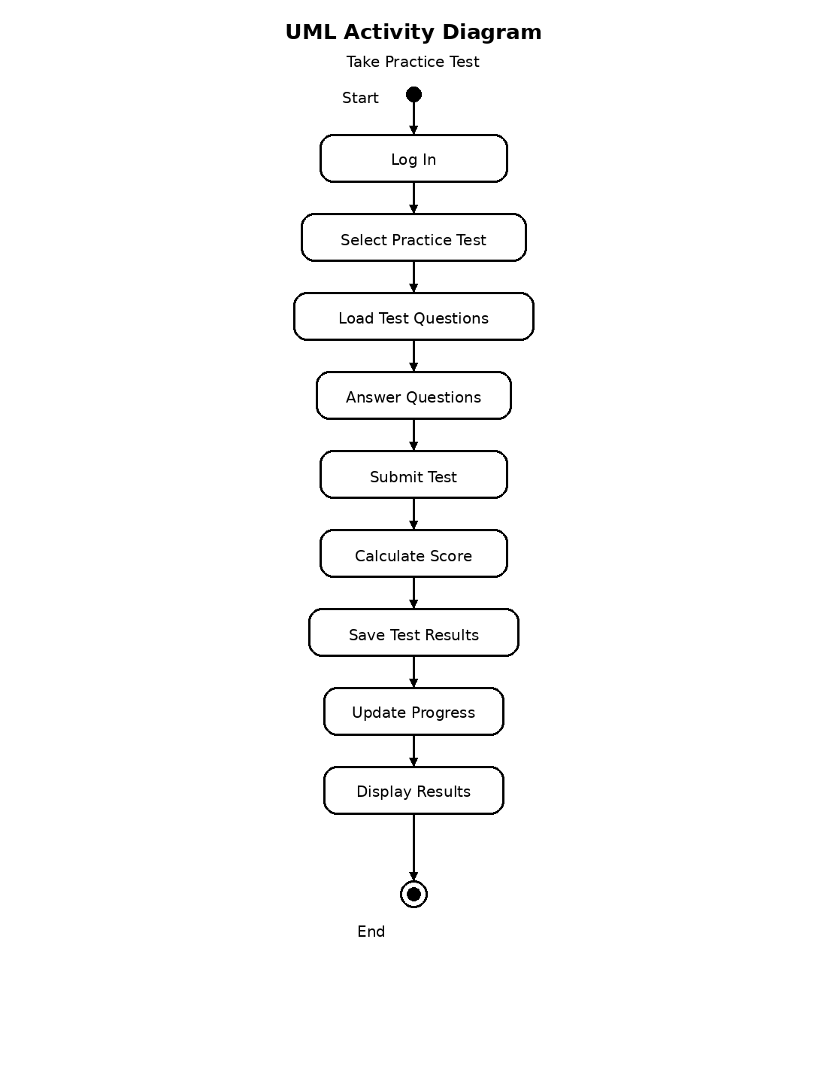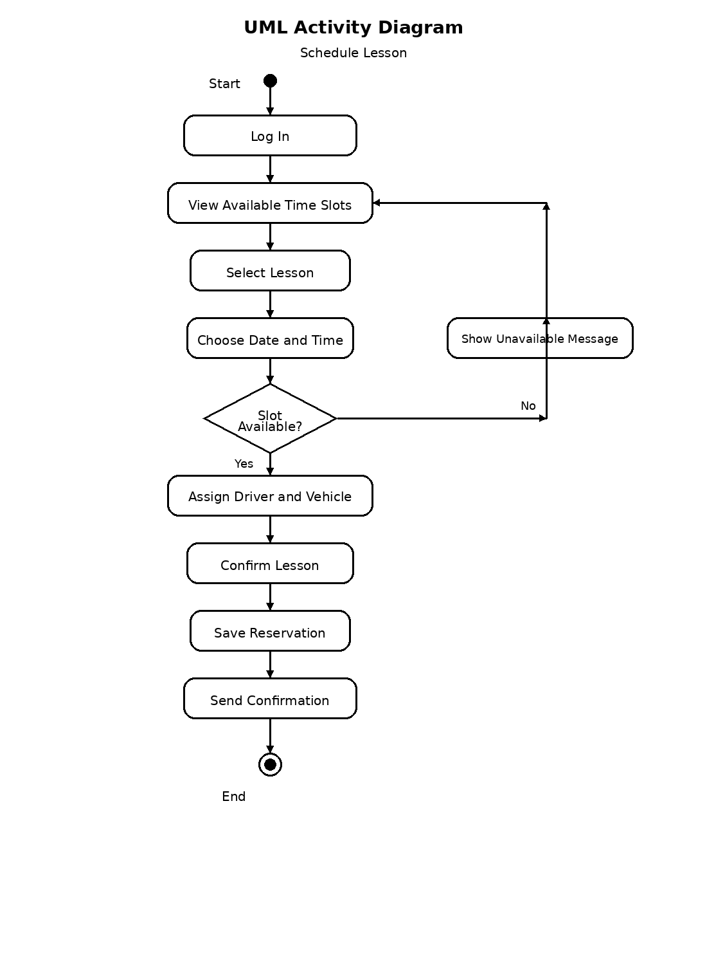

UML Sequence Diagram

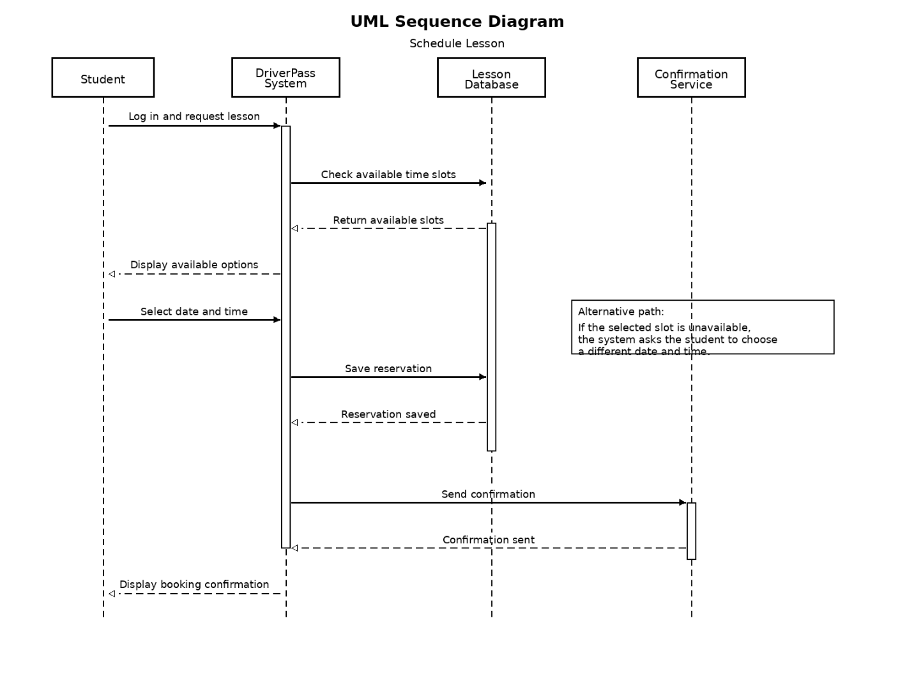

UML Class Diagram

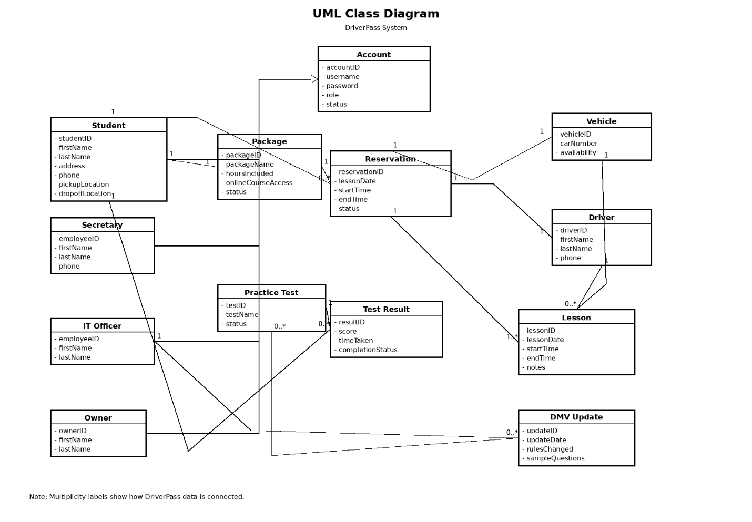

Technical Requirements
The DriverPass system should be built as a cloud-based web application so that users can access it from any location using a computer, tablet, or mobile device. The client specifically stated that the system needs to run over the web and preferably through the cloud because they do not want to manage backups, security, or other technical maintenance internally. The system must support access to business data from different devices while ensuring that changes are only made when the user is connected online so the company avoids duplicate or inconsistent records.

From a hardware standpoint, the system will require internet connected client devices for students, office staff, and management. These devices include desktop computers, laptops, tablets, and smartphones that can access the web application through a modern browser. On the business side, DriverPass will also need reliable internet access in the office so the secretary, owner, and IT officer can schedule lessons, manage accounts, generate reports, and monitor reservations. Because the system will store lesson schedules, driver assignments, customer records, and test information, the hosting environment should use secure cloud servers rather than local office servers. This approach aligns with the client’s request to minimize in-house technical problems and avoid handling backup and infrastructure tasks themselves.

From a software standpoint, the system should use a web-based application interface connected to a centralized database. The interface must allow students to register, log in, schedule driving lessons, modify or cancel reservations, take online classes, complete practice tests, and view their progress. It must also support office staff functions such as entering customer information, scheduling appointments by phone or in person, and viewing lesson schedules. In addition, the software must provide administrative functions for the IT officer, including password resets, account blocking, and account maintenance, along with reporting functions for the owner. These needs come directly from the client interview and are reflected in the UML diagrams created for the project.

The database infrastructure must support storage and retrieval of customer profiles, user accounts, lesson reservations, package information, vehicle assignments, driver records, practice test results, lesson notes, and DMV updates. Since the client wants to know who created, changed, or canceled reservations, the database should also store activity tracking information so reports can identify which user made a change. This is important for accountability and problem resolution. The system should be designed so that all users work from the same centralized data source, which improves consistency and reduces the risk of conflicting records.

Security is a major technical requirement for the DriverPass system. The client stated that different employees must have different rights and roles, which means the system must support role-based access control. Students should only be able to view and manage their own accounts and appointments. The secretary should be able to register customers and manage scheduling tasks. The IT officer should have full administrative access to user accounts for actions such as password resets and blocking access when necessary. The owner should have access to reports and operational information. Because the system will collect personal information and credit card details, secure authentication, protected data storage, and encrypted transmission of sensitive information are necessary. Audit tracking is also required so the company can review user actions when changes are made to reservations or records.

The system must also support integration with an external DMV update source. DriverPass wants its online training materials and practice tests to remain current with DMV rules, policies, and sample questions. Because of this, the system needs a way to receive updates and notify the business when DMV information changes. This requirement affects both the data design and the software design because updated rules and test content must be stored, managed, and reflected in the student learning features.

Finally, the system should include reporting and export capability so DriverPass can download reports and work with them outside the system, such as in Excel. This supports the owner’s request to review information at home and gives the business a practical way to analyze reservations, user activity, and operations. Overall, the technical requirements for DriverPass support a secure, cloud-based, role-aware, data-driven system that meets the scheduling, training, reporting, and account management needs described by the client.

